27 March 2026
NAME: HUMAIRA ISHAQ | Age: 20y | Sex: F
Clinical Details: OBS

REAL TIME PELVIC ULTRASONOGRAPHY EXAM: REVEALED:

URINARY BLADDER: Distended with urine with normal mucosal thickness. No gross masses or stone seen.

UTERUS: The uterus is gravid and shows single live fetus in the uterine cavity with good cardiac activity. The cervical Os is closed. Right and Left adnexa are free.

CUL-DE-SAC: No sonographic abnormalities detected in anterior and posterior cul-de-sac.

Biometry:
- CRL = 61 mm
- EGA = 12 weeks 03 day(s)
- EDD = 09/10/2026 (± 2 weeks)
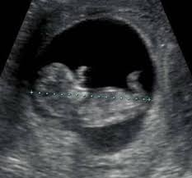

CONCLUSION: Single live embryo at 12 weeks 03 day (s) GA.
Sonographer.

